International coordination

Definition:
# Source: AI Source: Provided by: [Data Path: Persons Table -> ID Column: 1, Name_En Column: Motasem Essam] -> From: [ChatGPT] on [1/26/2026]
International coordination means countries and organizations working together globally to keep something consistent and synchronized across the whole world.
In the context of worldwide timekeeping, it refers to how different international scientific bodies cooperate to keep the world’s clocks accurate and unified.

Why coordination is needed
# Source: AI Source: Provided by: [Data Path: Persons Table -> ID Column: 1, Name_En Column: Motasem Essam] -> From: [ChatGPT] on [1/26/2026]
Time must be the same standard everywhere for:
- Internet and computers
- GPS and satellites
- Aviation and shipping
- Science and astronomy
- Banking and global trade
Without coordination, every country could drift apart in time, causing confusion and errors.

Main organizations involved
# Source: AI Source: Provided by: [Data Path: Persons Table -> ID Column: 1, Name_En Column: Motasem Essam] -> From: [ChatGPT] on [1/26/2026]
1. BIPM (International Bureau of Weights and Measures)
- Maintains International Atomic Time (TAI)
- Combines data from atomic clocks worldwide
- Helps define the official second
2. IERS (International Earth Rotation Service)
- Monitors Earth’s rotation
- Decides when to add leap seconds
- Keeps UTC aligned with Earth’s motion
3. ITU (International Telecommunication Union)
- Sets global standards for time signals
- Oversees how UTC is distributed worldwide

How coordination works
# Source: AI Source: Provided by: [Data Path: Persons Table -> ID Column: 1, Name_En Column: Motasem Essam] -> From: [ChatGPT] on [1/26/2026]
- Atomic clocks in many countries measure time precisely
- Data is shared internationally
- A unified global time (UTC) is calculated
- Time is broadcast worldwide (NTP servers, GPS, radio signals)

Diagram showing how BIPM, IERS, and ITU work together
# Source: AI Source: Provided by: [Data Path: Persons Table -> ID Column: 1, Name_En Column: Motasem Essam] -> From: [ChatGPT] on [1/26/2026]
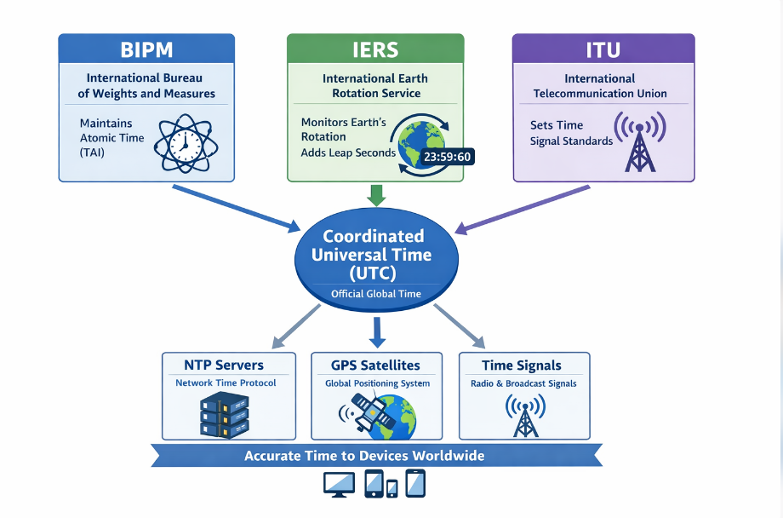
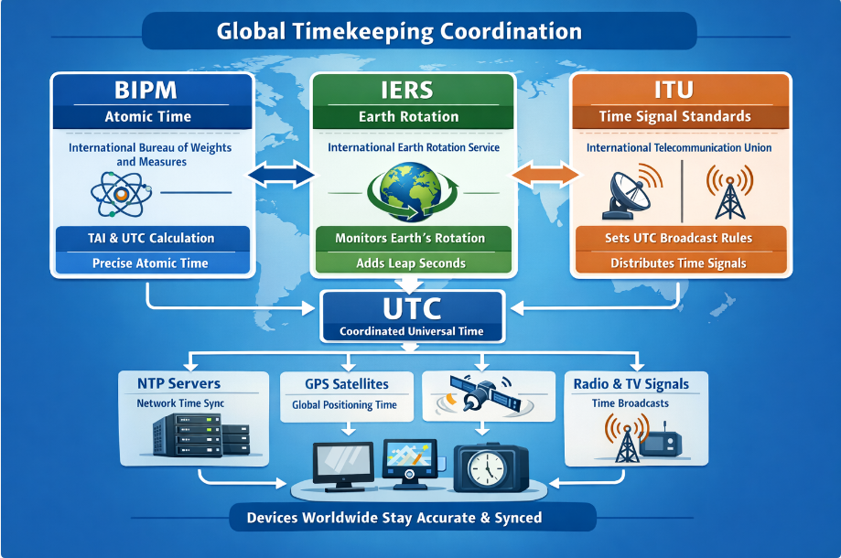

Simple meaning
# Source: AI Source: Provided by: [Data Path: Persons Table -> ID Column: 1, Name_En Column: Motasem Essam] -> From: [ChatGPT] on [1/26/2026]
International coordination = the world working together to keep one accurate global time.

